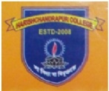

***H A R I S H C H A N D R A P U R C O L L E G E*** P.O.- PIPLA, DIST.- MALDA, PIN.- 732125, PH.- 03513-214003

Ref. No. August/2018/11 Date:- 31/08/2018

**N O T I F I C A T I O N**

The College will remain closed on 3rd September , 2018 on account of **JANMASTAMI**.

Sd/-

(Litan Biswas)

Teacher-in-Charge Harishchandrapur College, Malda.